1. Create a simple SpringBootApplication (Hello appln).

**HelloController.java**

package com.example.demo;

import org.springframework.web.bind.annotation.GetMapping;

import org.springframework.web.bind.annotation.RestController;

@RestController

public class HelloController {

@GetMapping("/")

public String index() {

return "Hello from Spring Boot!";

}

}

**HelloProjectApplication.java**

package com.example.demo;

import org.springframework.boot.SpringApplication;

import org.springframework.boot.autoconfigure.SpringBootApplication;

@SpringBootApplication

public class HelloprojectApplication {

public static void main(String[] args) {

SpringApplication.run(HelloprojectApplication.class, args);

}

}

**pom.xml**

<?xml version=*"1.0"* encoding=*"UTF-8"*?>

<project xmlns=*"http://maven.apache.org/POM/4.0.0"* xmlns:xsi=*"http://www.w3.org/2001/XMLSchema-instance"*

xsi:schemaLocation=*"http://maven.apache.org/POM/4.0.0 https://maven.apache.org/xsd/maven-4.0.0.xsd"*>

<modelVersion>4.0.0</modelVersion>

<parent>

<groupId>org.springframework.boot</groupId>

<artifactId>spring-boot-starter-parent</artifactId>

<version>2.5.4</version>

<relativePath/> <!-- lookup parent from repository -->

</parent>

<groupId>com.example</groupId>

<artifactId>helloproject</artifactId>

<version>0.0.1-SNAPSHOT</version>

<name>helloproject</name>

<description>Demo project for Spring Boot</description>

<properties>

<java.version>11</java.version>

</properties>

<dependencies>

<dependency>

<groupId>org.springframework.boot</groupId>

<artifactId>spring-boot-starter-thymeleaf</artifactId>

</dependency>

<dependency>

<groupId>org.springframework.boot</groupId>

<artifactId>spring-boot-starter-web</artifactId>

</dependency>

<dependency>

<groupId>org.springframework.boot</groupId>

<artifactId>spring-boot-devtools</artifactId>

<scope>runtime</scope>

<optional>true</optional>

</dependency>

<dependency>

<groupId>org.springframework.boot</groupId>

<artifactId>spring-boot-starter-test</artifactId>

<scope>test</scope>

</dependency>

</dependencies>

<build>

<plugins>

<plugin>

<groupId>org.springframework.boot</groupId>

<artifactId>spring-boot-maven-plugin</artifactId>

</plugin>

</plugins>

</build>

</project>

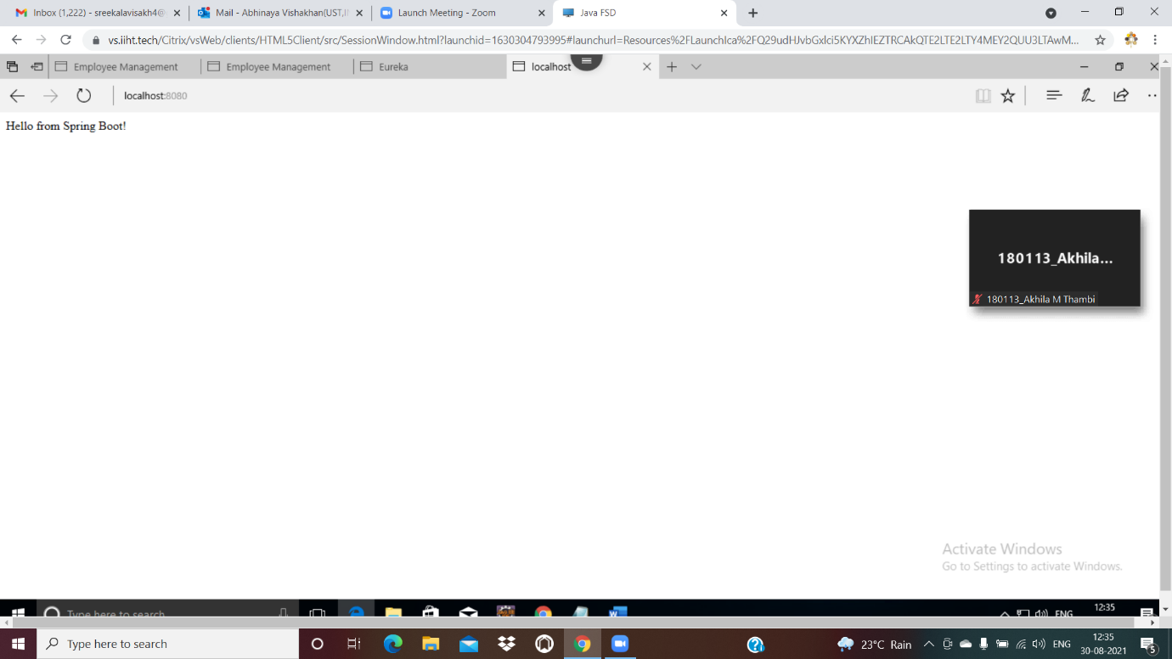

1. Create a Simple Microservice which contains one service talking to another microservice.

**Service 1-SpringA**



**Service 2-Springexample2**

pom.xml

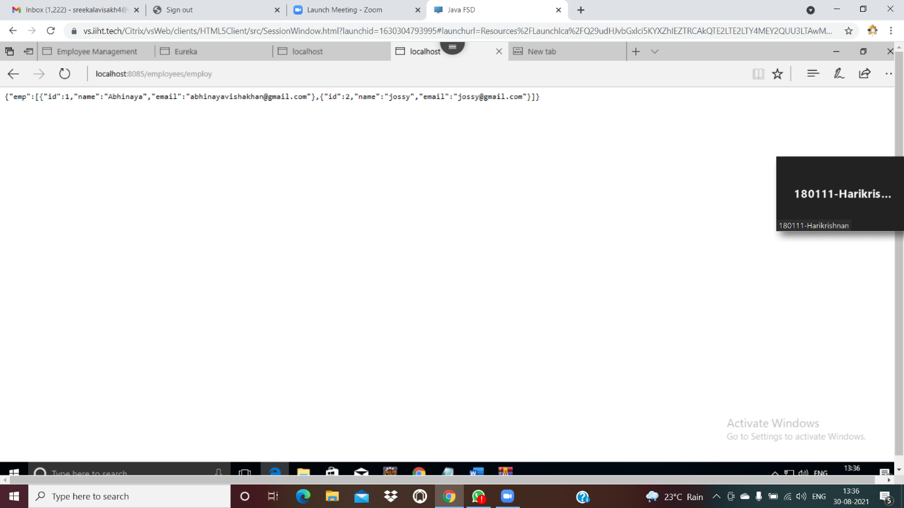

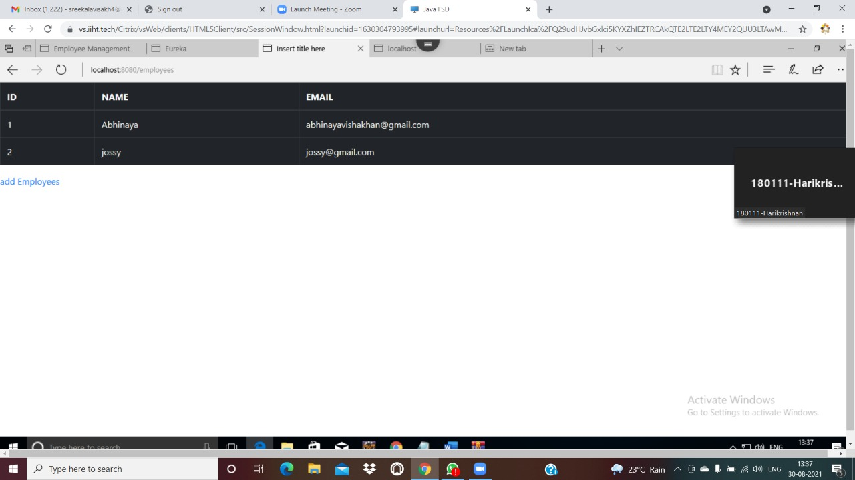

3.Create a microservice which has a fallback mechanism



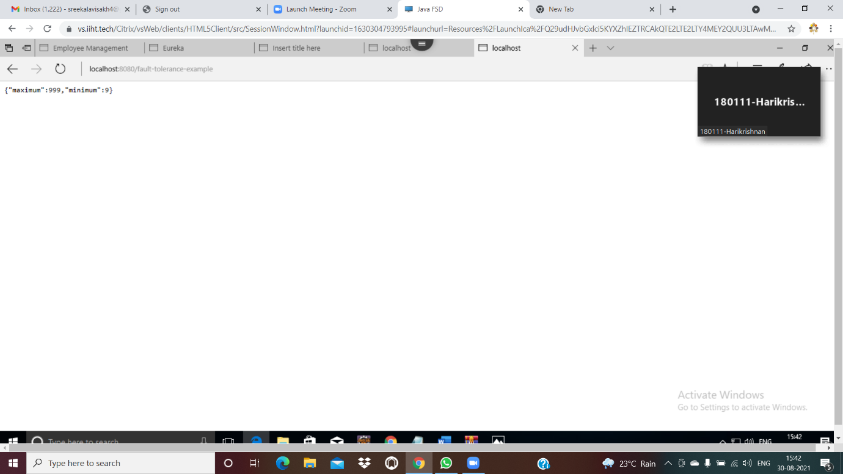

4. Create a microservice which uses Ribbon mechanism.

Currency-conversion -service





**currency exchange service**







